**Database Services - Assignment**

1. **MariaDB Assignment**
2. **Create a MariaDB Engine based RDS Database.**
3. **Connect to the DB using the following ways: a. SQL Client for Windows b. Linux based EC2 instance.**

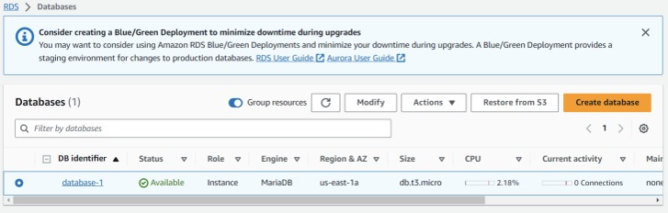

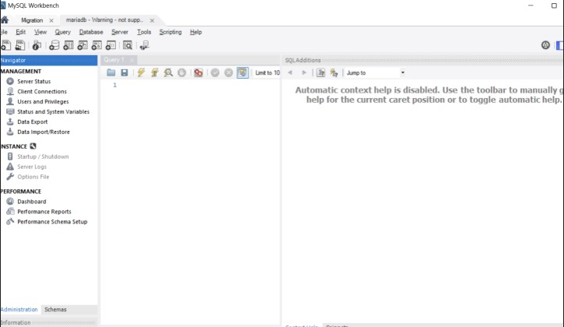

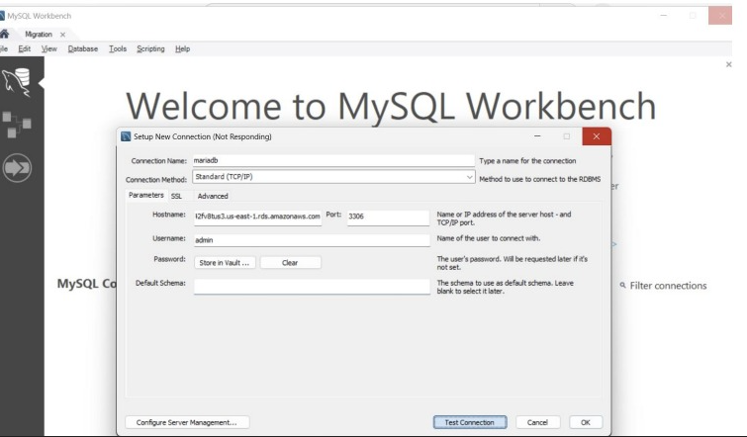

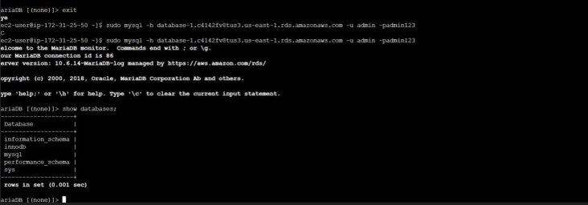

1. **Aurora Assignment**

**1. Create an AuroraDB Engine based RDS Database.**

**2. Create 2 Read Replicas in different availability zones for better infrastructure availability.**

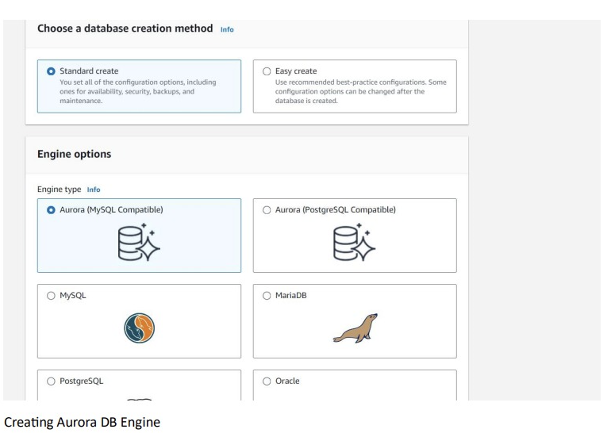

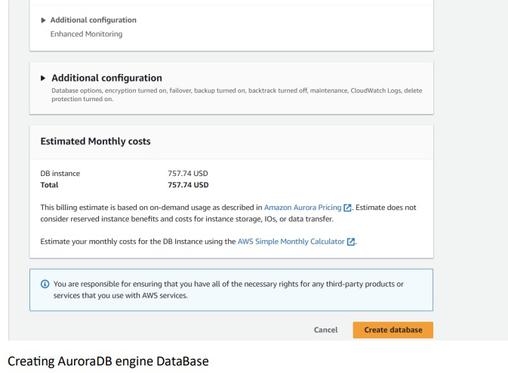

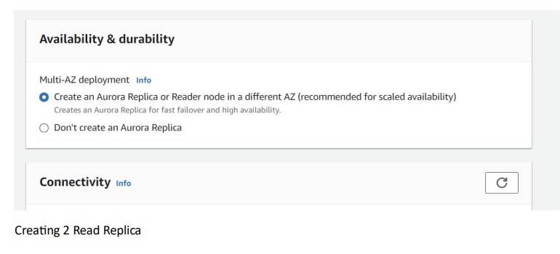

1. **Redshift Assignment**

**1. Create a Redshift data warehouse.**

**2. Using the query editor: a. Load some data b. Query the data**

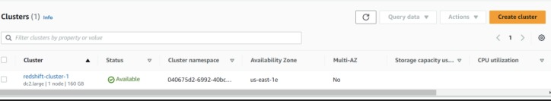

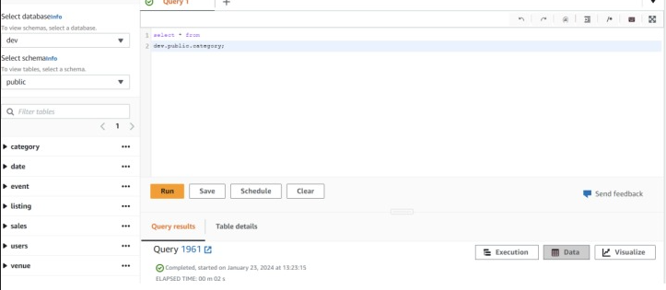

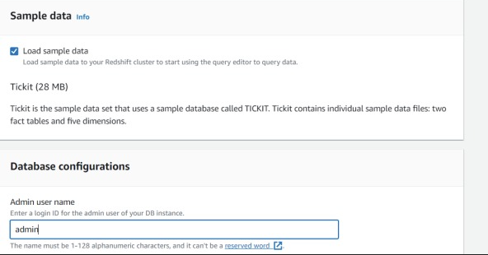

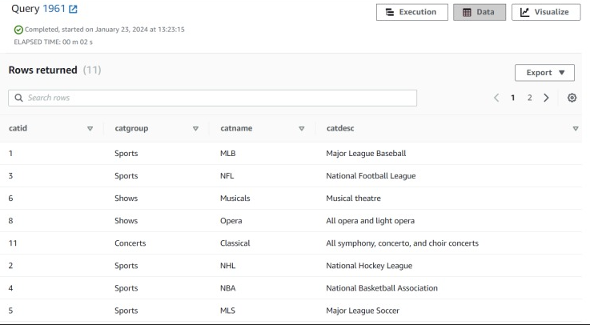

1. **DynamoDB Assignment**

**1. Create a DynamoDB table with partition key as ID.**

**2. Add 5 items to the DynamoDB table.**

**3. Take backup and delete the table.**

